**Custom Video Player App**

1. **Add Task Description:**

Creating a custom video player with play, pause, next, and previous functionality that using widgets loke Buttons, VideoView that plays videos from internal storage in Android Studio using Java programming.

1. **Attach Screenshot of Output.**

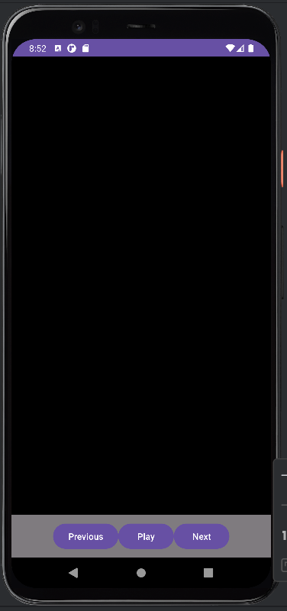

1. **Describe Widget/Algorithm Used In Task**

**Button:** Button widget use for Play/Pause, Next and Previous video play.

**ViderView:** Widget use to display video content to the users within android application.